Experiment / Case Study 1

Experiment Title: Demonstrate inline, internal, and external JavaScript; use console methods; create a webpage showing user info and a welcome message.
Software / Tools Required: VS Code, JavaScript, HTML/CSS, Web browser
Experiment Program Code:
JavaScriptTest.html (HTML/CSS File)
<html>
<head>
<title>JavaScript Test</title>
<script src="Desktop/TestScript.js"></script>
<script>
function showWelcome() {
let name = document.getElementById("name").value;
let age = document.getElementById("age").value;

document.getElementById("output").innerHTML =
"<h4>Welcome, " + name + "!</h4>" +
"<p>Your Age is: " + age + "</p>";

console.log("User Name: " + name);
console.info("User Age: " + age);
console.warn("This is a warning.");
console.error("This is an error (for demo).");
}

function addLine() {
document.getElementById("line").innerHTML =
"<p>Hello There.</p>";
}
</script>
</head>
<body style="background-color: azure;">
<h3 style="font-family:'Times New Roman', Times, serif">Hi. This is a test for JavaScript.</h3>
<div id="line"></div>
<label>Enter Name: </label>
<input type="text" id="name" placeholder="John Doe">
<br><br>
<label>Enter Age: </label>
<input type="number" id="age" placeholder="35">
<br><br>
<button onclick="showWelcome(); greet();">Click to see the result</button>
<br><br>
<button onclick="addLine();">Click to add a sample line.</button>
<hr>
<div id="output"></div>
<br><br>
<h3>Designed by Arunima Das, PRN: 24070521007</h3>
<script src="TestScript.js"></script>
</body>
</html>
TestScript.js (JavaScript File)
function greet() {
alert("Welcome to JS programming!");

console.table([
{
Name: "Sample User",
Course: "JavaScript"
}
]);

console.time("Execution");
console.timeEnd("Execution");
}

Output:
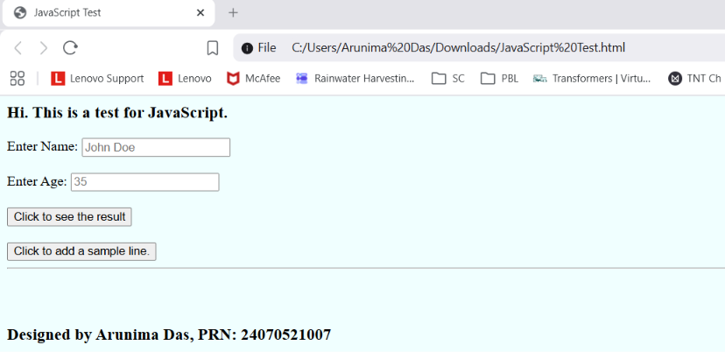
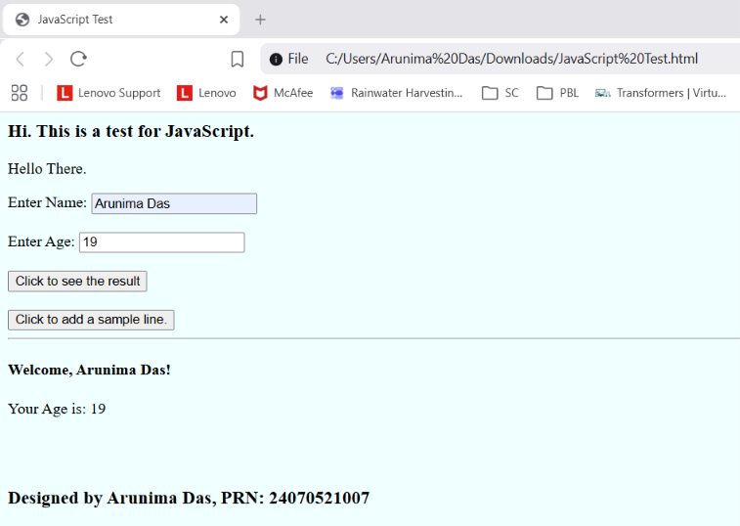
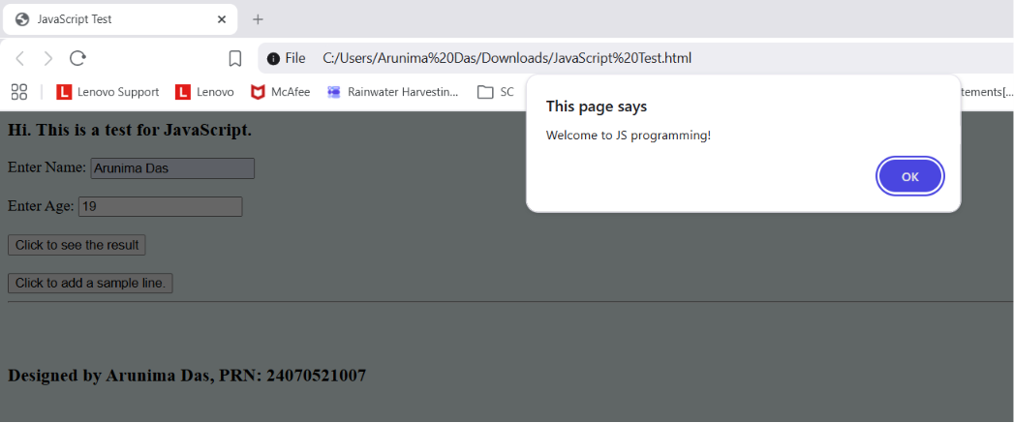

Case Study Title: Design a webpage for the college and link it to another webpage asking for student’s information. Display the student information.
Case Study Program Code:
IntroPage.html (HTML/CSS File for webpage)
<html>
<head>
<title>Symbiosis Institute of Technology, Nagpur</title>
<style>
.header {
margin-top: 0px;
height: 100px;
align-self: center;
font-family:'Franklin Gothic Medium', 'Arial Narrow', Arial, sans-serif;
color:crimson;
text-align: center;
background-color: rgb(219, 203, 203);
}

.card {
margin-top: 40px;
background-color: rgba(38, 98, 201, 0.8);
backdrop-filter: blur(4px);
border-radius: 20px;
padding: 40px 50px;
box-shadow: 0 8px 20px rgba(0, 0, 0, 0.25);
}

button {
margin-top: 15px;
background-color: rgb(241, 35, 35);
color: white;
font-size: 18px;
font-family: Arial, Helvetica, sans-serif;
border: none;
border-radius: 5px;
padding: 10px 20px;
cursor: pointer;
box-shadow: 0 3px 6px rgba(0, 0, 0, 0.4);
transition: transform 0.15s ease, background-color 0.15s ease;
}

button:hover {
background-color: rgb(200, 20, 20);
transform: scale(1.05);
}

</style>
</head>
<body style="background-image: url('contactus_banner.webp')">
<div class="header">
<h1>Symbiosis Institute of Technology</h1>
<h2>Computer Science and Engineering</h3>
</div>
<div class="card">
<p style="font-family: 'Franklin Gothic Medium', 'Arial Narrow', Arial, sans-serif; color: whitesmoke">Symbiosis Institute of Technology (SIT) Nagpur is one of the best engineering colleges in Nagpur established in 2021 inheriting splendid novelty, dynamism, and excellence in education. It is nurtured by the visionary ideas of Dr. S.B. Mujumdar, Chancellor (Symbiosis International University) on the principles of vedic thought 'Vasudhaiva Kutumbakam' which means 'World as One Family.' Symbiosis Institute of Technology, Nagpur is a member of Symbiosis International University, Pune, and is ideally positioned in Maharashtra's prospective education center-Nagpur, providing a plethora of possibilities for aspiring engineers.</p>
<button onclick="location.href='form.html'">Register Now!</button>
</div>
<h3>Designed by Arunima Das, PRN: 24070521007</h3>

</body>
</html>

Form.html (HTML/CSS File for form)
<html>
<head>
<title>Form for Student Information</title>
<style>
.header {
margin-top: 0px;
height: 140px;
align-self: center;
font-family:'Franklin Gothic Medium', 'Arial Narrow', Arial, sans-serif;
color:crimson;
text-align: center;
background-color: rgb(219, 203, 203);
}

.form {
margin-left: 20%;
margin-right: 20%;
margin-top: 60px;
background-color: rgb(146, 136, 136);
border-radius: 20px;
padding: 30px;

.label {
font-size: 25px;
font-family:'Gill Sans', 'Gill Sans MT', Calibri, 'Trebuchet MS', sans-serif;
}
.button {
size: 25px;
font-family: 'Gill Sans', 'Gill Sans MT', Calibri, 'Trebuchet MS', sans-serif;
}

.input {
border-radius: 10px;
font-size: 20px;
}
}

.input {
border-radius: 10px;
font-size: 20px;
}

.output {
text-align: center;
font-family: 'Franklin Gothic Medium', 'Arial Narrow', Arial, sans-serif;
background-color: rgb(218, 194, 165);
}

</style>
<script>
function welcomeStudent() {
let name = document.getElementById("name").value;
let age = document.getElementById("age").value;
let phone = document.getElementById("phone").value;
let email = document.getElementById("email").value;
let sem = document.getElementById("sem").value;
let sec = document.getElementById("sec").value;
let cgpa = document.getElementById("cgpa").value;

document.getElementById("output").innerHTML =
"<h2> Hi, " + name + "!</h2>" +
"<br>" +
"<h4> Your Age: " + age + "</h4>" +
"<br><br>" +
"<h4> Your Phone Number: " + phone + "</h4>" +
"<br>" +
"<h4> Your Email: " + email + "</h4>" +
"<br>" +
"<h4> Your Semester: " + sem + "</h4>" +
"<br>" +
"<h4> Your Section: " + sec + "</h4>" +
"<br>" +
"<h4> Your CGPA: " + cgpa + "</h4>" +
"<br>";

}

console.log("User Name: " + name);
console.log("User Age: " + age);
console.log("User Phone: " + phone);
console.log("User Email: " + email);
console.log("User Semester: " + sem);
console.log("User Section: " + sec);
console.log("User CGPA: " + cgpa);
</script>
</head>
<body>
<div class="header">
<h1>Symbiosis Institute of Technology</h1>
<h2>Computer Science and Engineering</h3>
<h4>Fill the form below</h4>
</div>
<div class="form">
<label class="label">Enter Name: </label>
<input type="text" id="name" placeholder="John Doe" class="input">
<br><br>
<label class="label">Enter Age: </label>
<input type="number" id="age" placeholder="18" class="input">
<br><br>
<label class="label">Enter Phone Number: </label>
<input type="phone" id="phone" placeholder="9999999999" class="input">
<br><br>
<label class="label">Enter Email: </label>
<input type="email" id="email" placeholder="example@mail.com" class="input">
<br><br>
<label class="label">Enter Semester: </label>
<input type="number" id="sem" class="input">
<br><br>
<label class="label">Enter Section: </label>
<input type="text" id="sec" class="input">
<br><br>
<label class="label">Enter CGPA: </label>
<input type="number" id="cgpa" class="input">
<br><br>
<button onclick="welcomeStudent(); greet();">Submit</button>
</div>
<br><br>
<hr>
<div id="output" class="output"></div>
<br><br>
<h3>Designed by Arunima Das, PRN: 24070521007</h3>
<script src="FormScript.js"></script>
</body>
</html>
FormScript.js (JavaScript File)
function greet() {
alert("Welcome to SIT Nagpur");
}

Output:
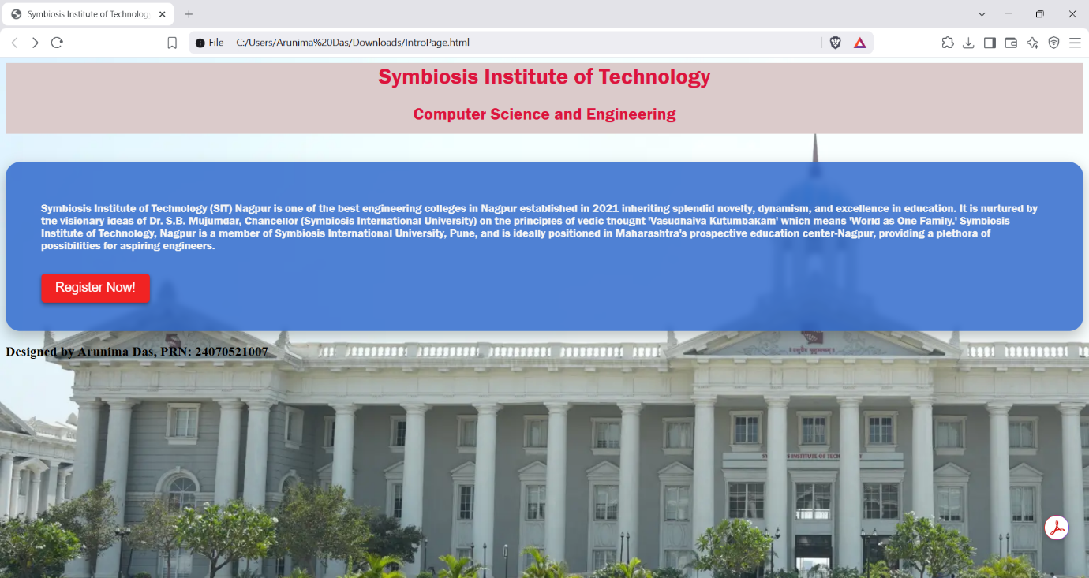
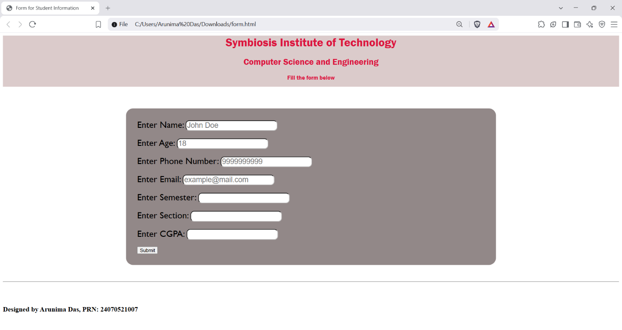
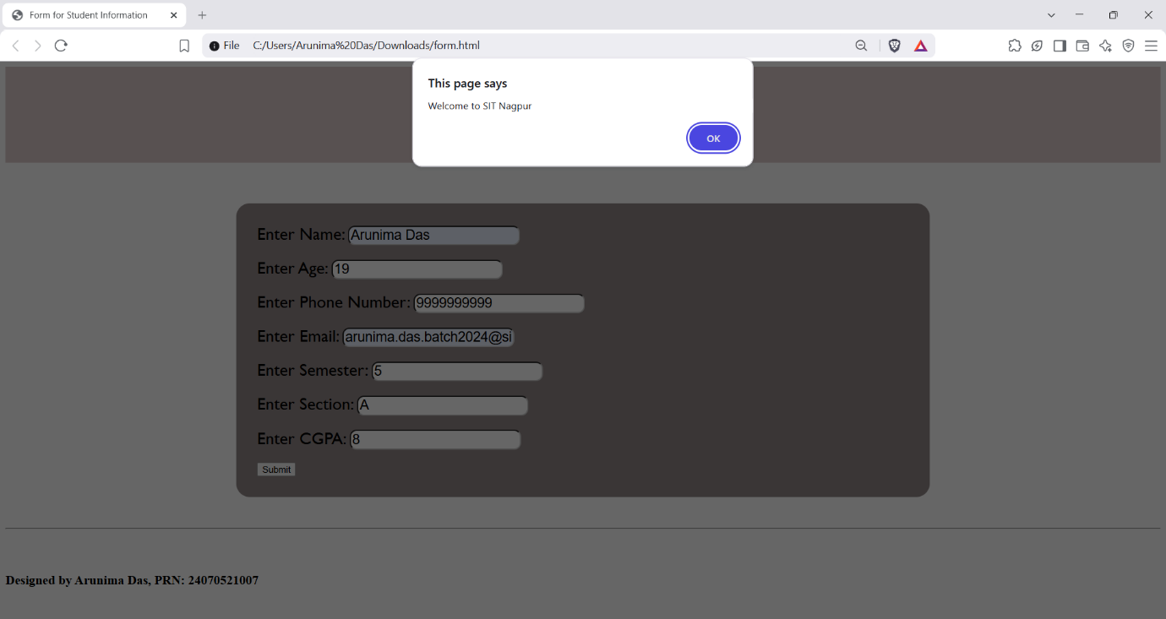
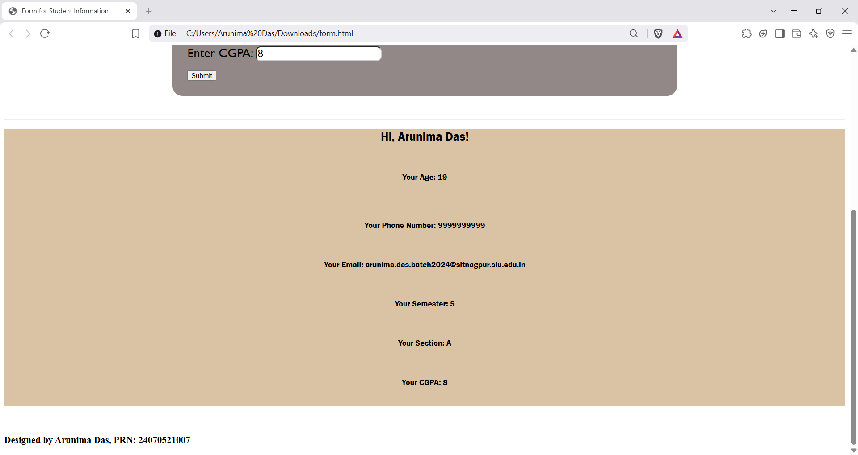

Conclusion: Hence, by combining the three ways to write JavaScript code, we can create a simple interface to handle users’ info and display them.

